Haggs Parish Church linked with Denny Old Parish Church of Scotland
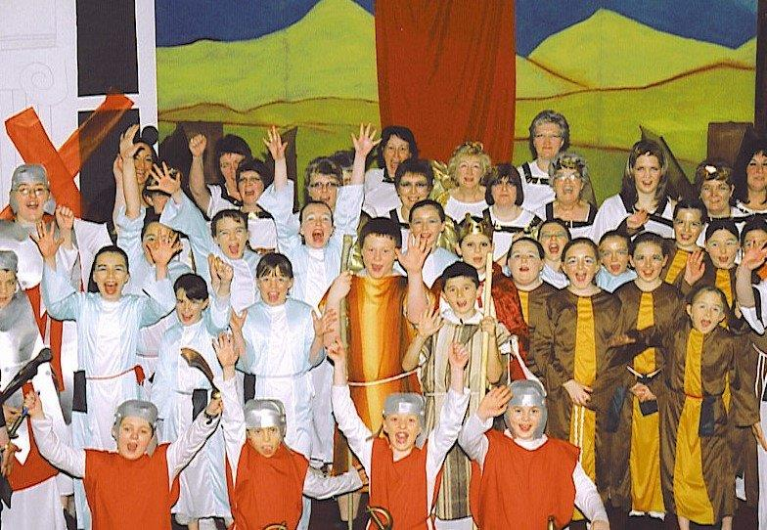
Welcome to the Parish Profile of the Linked Charge.
We thank you for taking the time to read our profile and we hope you find it informative.
For any other information or questions please contact our Interim Moderator.

In accordance with the Falkirk Presbytery Plan, Haggs Parish linked with Denny Old Parish Church of Scotland have permission to call a minister on an unrestricted tenure.
Haggs and Denny Old Churches are currently on an exciting journey as they seek to integrate the two congregations. Both Kirk Sessions see this as a wonderful opportunity for both congregations to get to know one another better, and to forge a stronger bond as they seek to take the message of the Gospel into their respective communities. Both congregation are very well served and supported by Kirk Sessions and Congregational Boards. There are historical links between the two churches as Haggs was originally a satellite church from Denny Old 175 years ago, and both churches feel there is a sense of coming home.
The congregations of Haggs and Denny Old are friendly, welcoming and outgoing. They have been joining in worship on a regular basis, including Christmas and Easter Services, and coming together through joint initiatives such as the combined choirs, Messy Church, and of course planning for their future together. Both congregations are looking forward to becoming involved in many other events in the coming months as well as sharing each other’s resources and talents

Our Churches’ Organisations
Church Based | Pastoral Care | Outreach
Guild | Bereavement Support | Yoga
Boy’s Brigade | Visitation Group for Old and Sick | 37 Club
Girl’s Brigade | Time Out Group for women who meet for a blether | Food Bank
Annual Ecumenical Service |  | Keep Fit /Indoor bowls
Crafty Café  Sharing/ making various crafts |  | Wakey Wakey - Breakfast Club at two local Primary Schools
Lunch Box  Weekly Café for Local Community |  | Homestart  Support Group for Parents and Children
Messy Church |  | Enjoy a Ball
Summer Club |  | Gaelic Choir
Blue Christmas Service for the Bereaved |  | Christian Aid
Tea/coffee after church service |  | Strathcarron Hospice
Monthly Soup and Sandwiches money going to charities |  | Home from home  Older people from church supporting young mums
***Please visit our websites for more details.
Manse
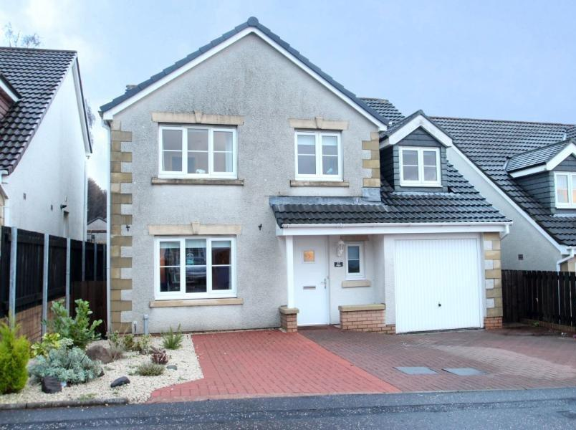

A modern detached manse with an easily maintained garden will be available.
The Manse is located in a popular residential area and is equidistant between
Denny Old and Haggs churches.
Our New Minister

We are currently seeking to call a minister who will join with us on our journey, and with the support of the Kirk Sessions and Boards, help lead our congregations as we travel on this new and exciting road together.

We are looking for someone to lead and work with us in spreading the Good News in our communities by:

- Motivating us by the preaching of God’s word and providing good pastoral care.
- Developing our personal faith, and by providing opportunities to participate in worship in our churches
- Having a compassionate approach with good interpersonal skills.
- Communicating across a diverse community of people in our parishes.
- Having a good sense of humour would also be welcome!

As Kirk Sessions, Boards and congregations you will find us:

- Supportive, friendly and welcoming.
- Willing to work as a team.
- Participative in temporal matters and willing to develop our involvement in worship.
- Supportive in the use of our advanced audio-visual systems.
- Willing to continue to develop joint initiatives with our churches.
- Willing to share in pastoral care within our churches.
- Continuing in our outreach activities and be supportive of new initiatives from the wider church to be more effectively engaged in our local communities.

There is a fraternity of local ministers.

Following separate Kirk Sessions’ deliberations with regard to human sexuality there was a range of views; the outcome being to remain with the Traditional View.
We continue to share our worship at regular intervals and to work together to show our love by serving Christ in our churches and communities, providing a warm welcome to all in the name of the Lord Jesus Christ.
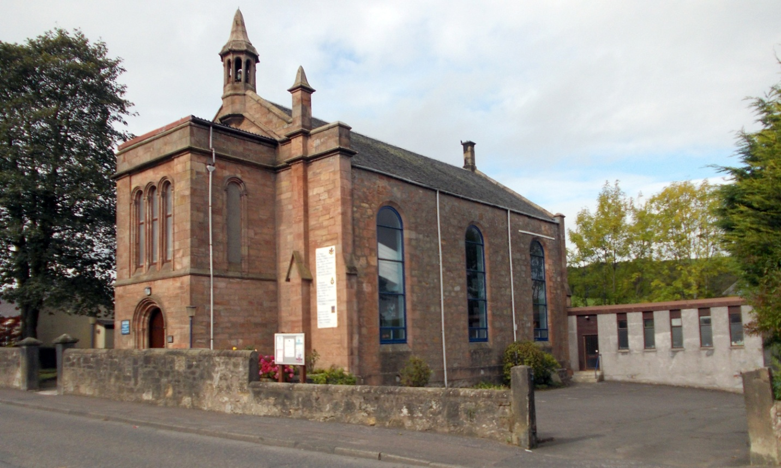
Haggs Parish Church

Vision Statement

Haggs Parish Church was founded in 1840 to share the witness of God’s love. We the present day people of Haggs, seek to show that love by serving Christ In our church and community, with whole hearted commitment.
Along with Denny Old we acknowledge the worth of individuals and encourage the development of their talents, while maintaining a unity of purpose in our service to God.
We recognise the need for mission and outreach within our Parish and plan to create greater community awareness of what our church has to offer.
All our aims are based on a sure belief in the character and teaching of Christ and, with God’s help, this vision can be fulfilled as we go forward in faith.

website: www.haggschurch.org.uk
email: haggschurch1@yahoo.co.uk
Scottish Charity No. SC014536
The Parish

Haggs Parish is situated at the western end of Falkirk Presbytery where it borders the Glasgow Presbytery. The Parish covers an area of approximately six square miles serving a population of roughly five thousand five hundred in the communities of Coneypark, Banknock, Haggs, Longcroft, Dennyloanhead, Allandale and Head of Muir. A once small collection of villages is now joined by extensive new house building strung along both sides of the road.
Several new private estates have been built to add to the existing local authority housing now mainly owner occupier, with proposed new housing outlined for construction in the future. There are several shops, small supermarket, hairdressers, garage, restaurants and hotels and a range of small businesses exist throughout the area.
St Luke’s Roman Catholic Church in Haggs serves the Roman Catholic population of the Parish.

Amenities

Two Primary Schools with one secondary school located in nearby Denny.
Bankier Primary in Banknock with approx. 230 pupils including nursery pupils.
Head of Muir Primary with 392 pupils including 30 nursery pupils situated in Haypark Road, Head of Muir.
Bankview Care Home, Kilsyth Road, Banknock.
Archibald Russell Centre and Banknock Community Hall.
Pharmacy, Post Office in Scotmid Co-op supermarket at Haggs and a further P.O. in Head of Muir Scotmid Co-op, plus several smaller shops in the area.
A Medical Centre based at Banknock
Forth Valley Royal Hospital is only 4 miles from Haggs at Larbert.
Bowling green and local football park are located at Allandale.
Close proximity to Forth and Clyde Canal for recreation, walking and cycling.

The Congregation

We are a church serving God at the heart of the community of Haggs Parish.
The Haggs Parish Church of today is an active community of faith even although the majority of the membership is in the older age group they are hardworking and committed to their respective roles. Through this commitment our Christian giving for others amounted to £3,985.00 of which Christian Aid received £2,715.00 in 2015.
The congregational roll shows 231 members with 77 on the supplementary roll. The Office bearers consist of 22 female and 9 male.
We have regular services of worship and a number of youth and adult organisations. The Sunday Club for the younger members of our church family leaves after the children’s talk on a Sunday morning when they go to continue their own worship and activities. The finances of the Church are looked after by the Congregational Board while the spiritual wellbeing of our members is taken care of by the Kirk Session, who meet every two months as a court of the Church and as and when required.
Transport

Haggs parish is ideally situated in the centre of Scotland.
Close proximity to M80 for Stirling and the north and west for Glasgow.
The M73 for Carlisle and the south are within easy access and the M876 (M9)
to Edinburgh only 28 miles away.
Glasgow 20 miles, Cumbernauld 3 miles, Stirling 10 miles and Falkirk 4 miles.
Rail Links at Cumbernauld, Croy, Camelon, Larbert, Falkirk Grahamston and Falkirk High.
Bus links to Glasgow, Stirling, Falkirk and the local area

Worship

There is a weekly Sunday morning service at 9.45am or 11.15 am (times will alternate annually in October) where worshippers are welcomed at the door by the duty team.
Formal Communion is celebrated twice a year in March and October.
Informal Communion at the behest of the Minister.
We have a sound system which includes a loop system for the hard of hearing and an overhead projector for order of service.
We have a CCLI licence to use the Good News Bible, CH4, Mission and Junior Praise for music. We have a small choir who lead us in worship and a rota for Organist cover.

Property
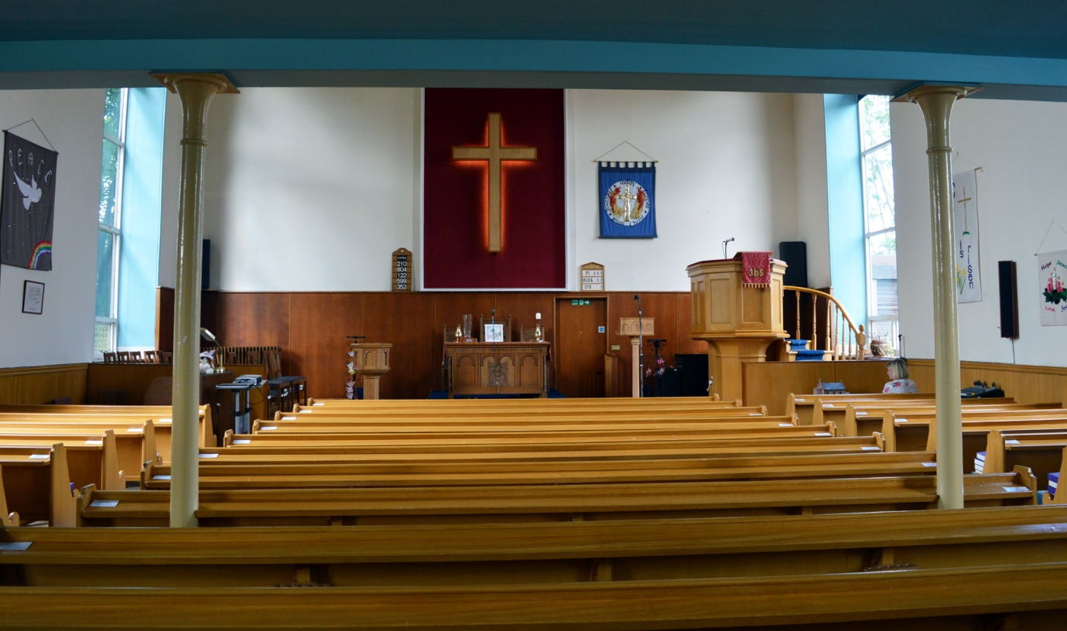

Haggs Church was built in 1840 and in 2015 we celebrated 175 years of witness in the area, we have a small hall built on to the side of church and the Main Hall is situated 50 yards from the Church entrance.

Finance

The finance of the Church is sound and a copy of the most recent accounts can be provided on request.

Denny Old Parish Church
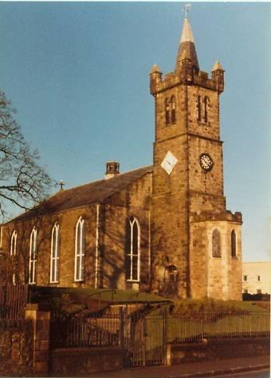

Vision Statement
Our Mission is to promote the Good News of the Gospel in our Local Community and to be an outward looking, forward thinking, all-embracing Church community that provides a warm welcome to all in the name of the Lord Jesus Christ.
Along with Haggs Parish Church we acknowledge the worth of individuals and encourage the development of their talents, while maintaining a unity of purpose in our service to God.
We recognise the need for mission and outreach within our parish and plan to create a greater community awareness of what our church has to offer.
All our aims are based on a sure belief in the character and teaching of Christ, and with Gods help, we are assured that this vision can be fulfilled as we go forward in faith.
website: dennyoldparish.wix.com/dennyold
email: info@dennyoldparishchurch.org
Scottish Charity No: SC016255
The Congregation
We are a church serving God at the heart of the community of Denny.
The Parish of Denny Old was first established in 1601 and we celebrated our 400th Anniversary in 2001. Our present church is centrally located at “Denny Cross” is the third to have occupied the site and was built in 1815 with extensive modifications in 1928. It is in very good condition and has seating capacity for around 600 people. There is a well maintained traditional pipe organ. There is a new multimedia system as well as an induction loop for those who require it.
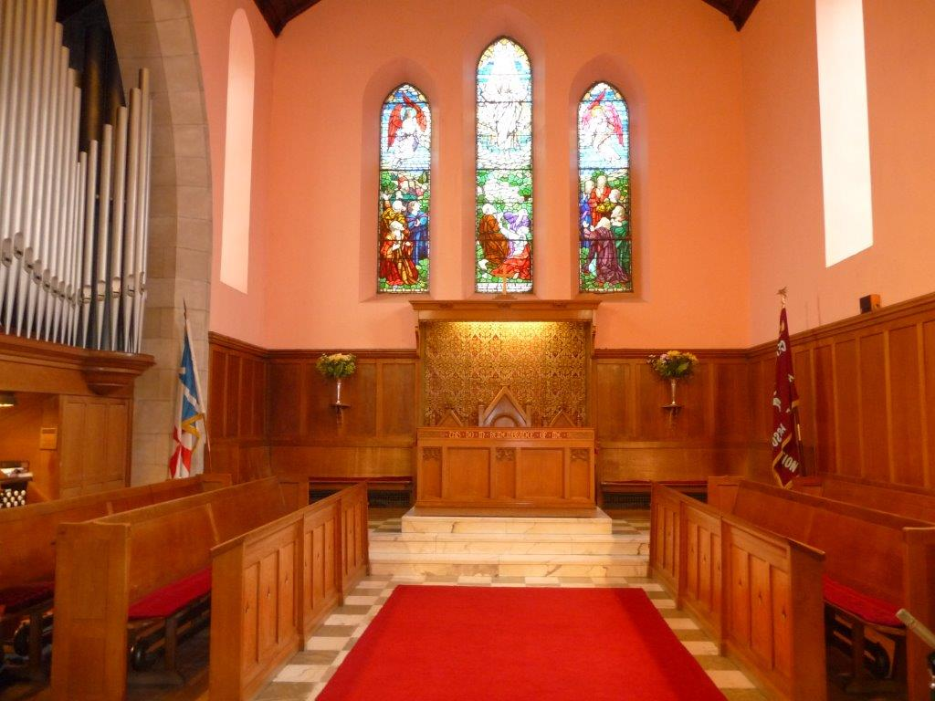

The halls which adjoin the church were enlarged in the early 1990’s and are made up of the main hall, the lesser hall, a small meeting room together with male and female and disabled toilets and kitchen. Recent work has improved disabled access to the buildings. The fabric of the halls is in good repair.
There are 343 members on communion roll at end 2015, with 87 on the Supplementary Roll, and 14 Adherents. Over the last 3 years, on average there have been 6 baptisms, 4 weddings and 30 funerals annually.
The Congregational finances are in a healthy state with Ministries and Mission being met in full. As well as raising a substantial amount of money for the church, the Lunch Box and Church Fayre reach out to the local community in the spirit of friendship and harmony.
Worship

Theologically our church is liberal in nature and our worship reflects this. Our church worship is on Sundays at 9.45am or 11.15 am (times will alternate annually in October). Our Sunday Club and Bible Class attend the beginning of the service and leave after the children’s address and meet in the adjoining halls. A crèche is available every Sunday for young children. Holy Communion is celebrated on the last Sunday’s of April and October and on Easter Sunday. There is a strong musical tradition in the church.

The Parish

Denny is divided into two parishes and the area we have responsibility for has a population of around 6000. Relationships with the other churches in the town are good. During Holy Week all the churches in the local area share the worship together. There is one other Church of Scotland church in Denny with another in nearby Dunipace, along with Denny Baptist Church and St. Alexander’s Roman Catholic Church.

Amenities

The main town of Denny is undergoing regeneration at present to create a newly developed town centre. There are smaller shops, supermarkets, banks, library, sports centre with the use of Denny High’s swimming pool. Denny has three primary schools and a modern secondary school. The church has a close working relationship with the local Primary School and Secondary School. There are two medical practices along with the new Forth Valley hospital in Larbert, four miles away. In Denny there has been a recent surge in new housing giving new opportunities to develop outreach initiatives.

Location

The congregations of Haggs and Denny Old are 3 miles apart. Within a ten-minute drive from the Motorway networks and train stations, in Falkirk (5miles) and Stirling (7miles), give easy and quick access to the major cities, as well as the many wonderful outdoor activities offered in the heart of Scotland.
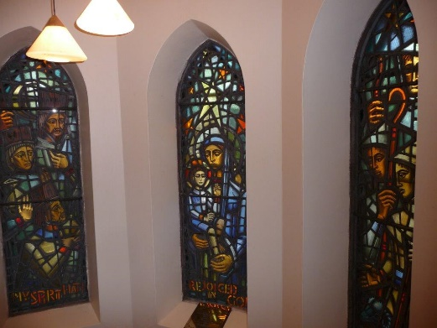

Contacts

For informal enquiries please contact:

Interim Moderator:

Mr David Nicholson DCS
2d Doonside
Kildrum
Cumbernauld
GLASGOW.
G67 2HX

01236 732260

DNicholson@churchofscotland.org.uk

Chairperson of Nominating Committee:

Jean Duff
28 Kirkland Drive,
Stoneywood,
Denny,
Stirlingshire.
FK6 5JA

01324 824768

jeanduff8@gmail.com

For further information and to submit an application and CV please contact:

Clerk to Nominating Committee:

Janet Rhodes,
7 Lochhead Avenue,
Denny
Stirlingshire
FK6 5EQ

01324 824721

janet.stewart@blueyonder.co.uk

